Tool Guide – Testssl

Introduction
Safety Disclaimer: Use only on networks and systems for which you have explicit authorisation. Unauthorized use of tools can be Illegal, unethical and harmful.

Setup and Launch
  - Step1: Open Deakin Detonator Toolkit
- Open Terminal in Linux
- Navigate to your Deakin Detonator Toolkit directory: (cd ~/Deakin-Detonator-Toolkit)
- Run DDT by using the following command line: (yarn run tauri dev)
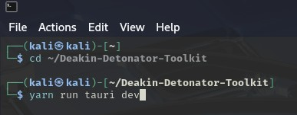
  - Step2: Find Tool-example
- Click on Tools to the left (or use the quick search bar)
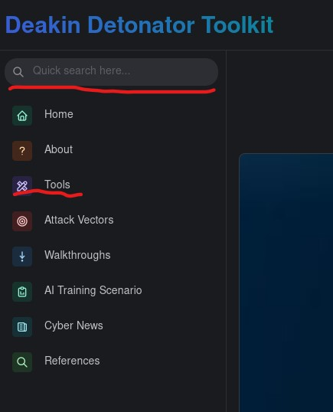
- If you clicked on Tools, scroll down and find Testssl and click go

Configuration and Usage
  - Step3: Configuring Testssl
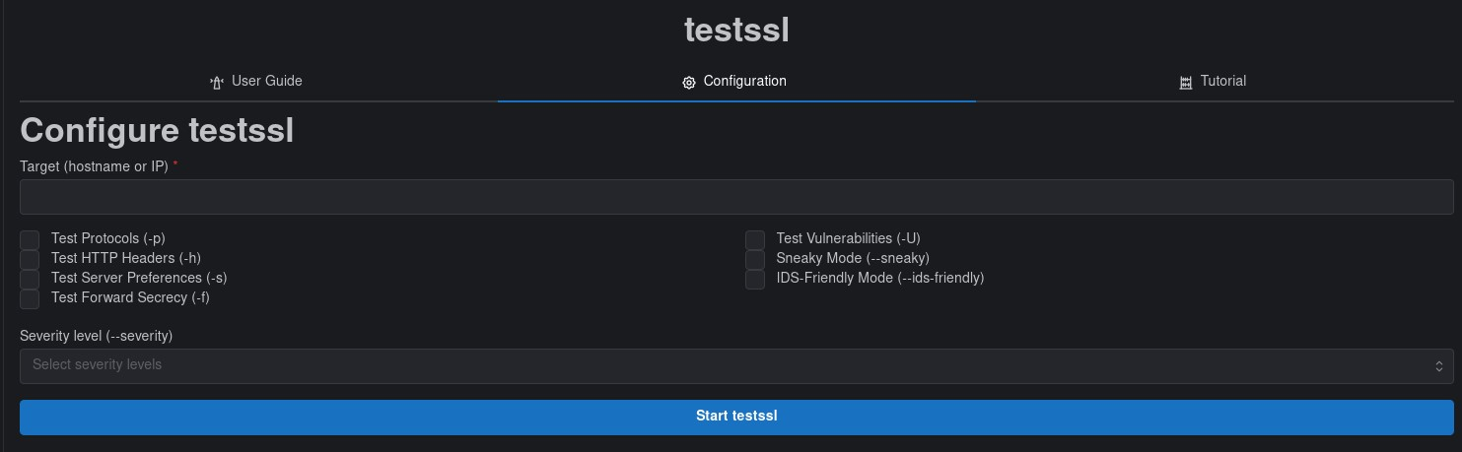
- Enter target (hostname or IP address) into “Target (hostname or IP)” field. E.g. google.com or 8.8.8.8
- Select the modifiers you wish to use, refer to the table below.
Option | Explanation
Test Protocols (-p) | Probes which SSL/TLS protocol version the server accepts
Test HTTP Headers (-h) | Checks HTTP-level security headers on HTTPS services
Test Server Preferences (-s) | Inspects the server’s preferred cipher ordering
Test Forward Secrecy (-f) | Tests if the server supports ephemeral key exchanges.
Test Vulnerabilities (-U) | Runs checks for known tls/ssl vulnerabilities and CVE’s
Sneaky Mode (--sneaky) | Reduces the “noisiness” of the scan, less aggressive probes, fewer connection attempts.
IDS-Friendly Mode (--ids-friendly) | Throttles and spaces tests to reduce chances of triggering intrusion detection systems.

- Input a Severity level. (low, medium, high and critical)
  - This functions as a report filter, it will show you what it finds from what you select.

  - Step4: Results
- You will be given an output that should end with “process completed successfully” and be sure to scroll up in the Output field to see the rest.
- Optional: You can save your output by filling out the new “Output filename” field with an appropriate name (output.txt) and then clicking “Save Output To File” button
- Optional: You can copy your output to your clipboard by clicking the little clipboard in the top-right of the output area.

Output Explanation
Note: your output will naturally be dependent on what domain you used and your settings, the following is non-comprehensive example output of what you could get from using Testssl on domain “example.com”.
- First thing you should see is a summary/header
- Followed by supported protocols, SSL/TLS protocols
  - SSL 2.0 not offered
  - TLS 1.2 offered (server preferred)
- Potentially some cipher suites, for example
  - TLS 1.3
TLS_AES_256_GCM_SHA384 Kx=any Au=ECDSA Enc=AESGCM(256) Mac=AEAD FS=Y (server yes)
- Forward secrecy & key exchange
  - ECDHE Supported (preferred)
  - DHE Not supported
- Around here you may see a certificate summary
- Followed by OCSP stapling
- HTTP security headers if you clicked that option
- And Vulnerability Checks (if selected)
  - Heartbleed (CVE-2014-0160) not vulnerable
- Server Preferences
- Final grade

